**Use our general accessibility guide to see resources for all of our programs.** [Click here](https://www.canva.com/design/DAFnOVOIrwI/6vrMKm1lky3330jVCSjouA/edit?utm_content=DAFnOVOIrwI&utm_campaign=designshare&utm_medium=link2&utm_source=sharebutton)   
   
If you’re looking for specific country information, see below.  

**Chile**

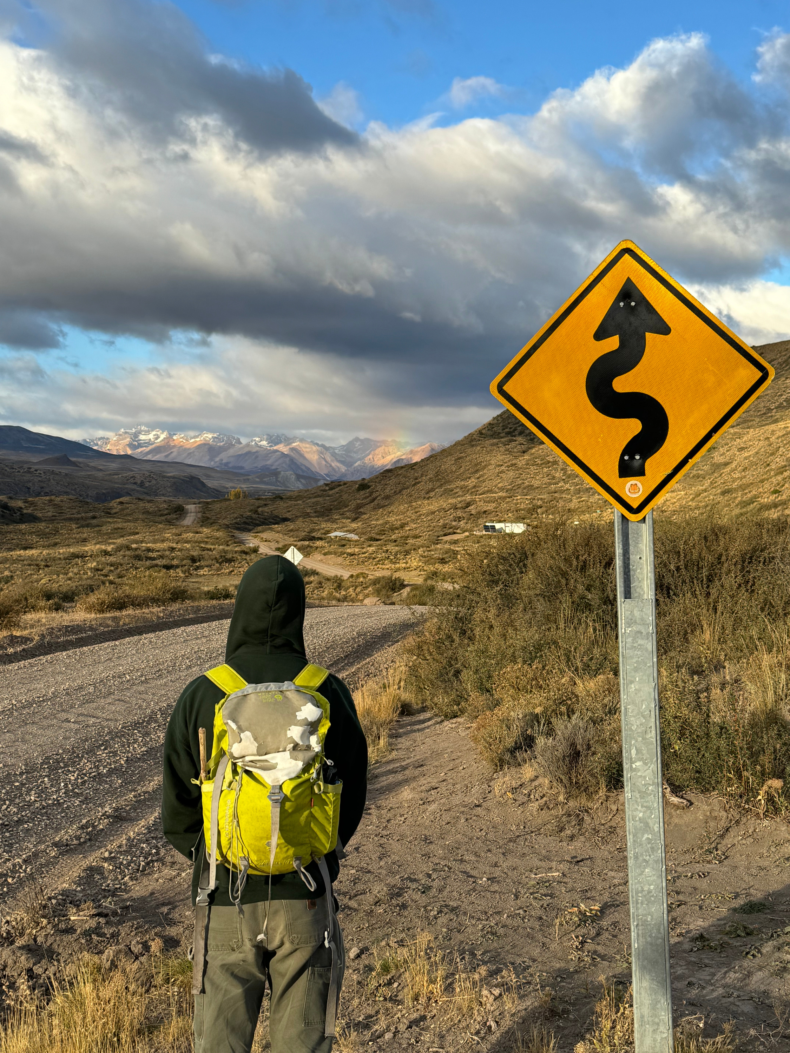

Helpful information about your country destination and planned activities

Check the website for examples of past syllabi <https://www.forestry.oregonstate.edu/international/where-andes-meets-sea-study-and-intern-patagonia-chile>

**Table of Contents**

* Travel
* Physical Activity (Program plan)
* Lodging
* Food
* Environment
* Culture
* Country Rules
* Academics

**Traveling to the program site**

You need to arrive in Puerto Montt NO LATER than 4:00pm on Saturday, February 1. If you arrive later than this, we will provide you with information for an Uber/taxi. In order to arrive on February 1, you’ll need to depart the U.S. on Friday, January 31. Make sure that you have at least 2 hours on your layover in Santiago on your way to Chile. A bus from the airport in Puerto Montt to the field station in Fruitillar will be arranged by your leaders. If you arrive earlier than F1, you will be responsible to be at the airport in Puerto Montt for pick up on Feb 1. You will not need a visa for this trip if you are traveling on a US passport! However, you will need a passport that is in good condition and valid for the period of stay. Make sure your passport is valid for another six months at minimum before you depart for international travel. If you are entering Chile via Santiago, you will have to go through customs there. Follow signs for domestic travel once in the airport to continue on to Balmaceda and enter the customs line. When you get in the customs line you will be asked for your passport and the address of where you are staying. It is fine to use the address for the Entre Cumbres Hotel in Coyhaique (**Prat 340, Coyhaique, Chile**) and you can say you are there for recreation or academic reasons. They will give you a slip of paper called a PDI (Chilean Immigration Police) documentation slip - DO NOT LOSE THIS. Please keep this piece of paper in a safe place until you are ready to leave Chile at the end of the trip as they will ask for it back on your return trip. If you do not have it you could be subject to a fee.

**Hikes/Physical Activity**

Activities include rafting in Rio Baker and backpacking in Cerro Castillo on the Las Horquetas trail. Students will participate in white water rafting at Puerto Bertrand along the Baker River.

Backpacking up to 15miles a day while carrying a pack of 20lbs+

Tent camping in variable weather (3 nights)

Rafting (no prior experience necessary)

**Lodging**

During our time in Frutillar, we will be staying at the Universidad de Chile Field Station, which offers dorm-style rooms, group meals, and beautiful paths through the surrounding forest. Located just outside Frutillar Bajo, it is close to town and provides a great opportunity to visit the local scene. While in Ancud, in the northern part of Chiloé Island, we will be staying in the Senda Darwin Biological Field StationLinks to an external site.. This lodging also offers dorm-style rooms, each housing 4 people. It is a cozy accommodation surrounded by nature. The first stop on the trip to Coyhaique will be in Hornopirén, where we will stay at Quelen Austral.The second stop will be in Chaitén, at Tranqueras del Monte. The third stop will be in Puyuhuapi, at El Pionero Hostal y Cabañas. During our days in Coyhaique, we will stay at the Esquina Patagónica Hostel. Located in downtown Coyhaique, this colorful hostel offers the opportunity to visit restaurants, local markets, the central square, and much more!

**Food**

Mostly groceries bought during the trip.

Leaders have participants’ dietary restrictions already and will buy accordingly. Participants can buy or bring extra food/nutrition to supplement if desired.

Lunch is the main meal of the day; business lunches are popular, and may be lengthy. Many Chileans eat a late afternoon snack ("la once") of cheese or sweets and tea or coffee (around 7 p.m.) or dinner after 8 p.m.

Popular local foods include seafood, empanadas (meat- or cheese-filled pastries), porotos granados (a bean-vegetable stew), and grilled meats (asado or parrillada), as well as cazuela (meat stew with potatoes and squash), humitas (tamale-like cornmeal and herb dish), and the beef and corn casserole, pastel de choclo. In Chile, sopaipillas are fried squash patties. Pisco (grape brandy) and local wines are popular beverages.

**Environment**

You'll be at roughly the same latitude as Oregon during your time in Chile, so you'll experience late summer and early Fall. Late March feels like the end of September in Oregon. There is some fluctuation of temperature and precipitation in Western Oregon, characterized by warm-dry summers and cold-wet winters. Most of Patagonia - specifically Coyhaique - receives 30% less precipitation than Corvallis, OR, but it is more uniformly distributed throughout the year.

If you want to compare the weather of Coyhaique with that of your hometown, remember to compare January through December from one place with July through June for the other place, as they are located in different hemispheres

**Culture**

Greet everyone individually upon arrival. Good topics of conversation include family, sports (especially soccer which is called football everywhere outside the US), international travel, and local sights. Chileans are proud of local traditions of poetry, literature, folk music, and wine making. Avoid speaking in a raised voice; soft-spoken voices are respected. The official currency is the Chilean peso (CLP). Some businesses in Santiago accept US dollars, but this option is very limited. 1 USD = 1,001.34 CLP as of 1/8/25.

**Country laws**

Visitors must respect the preservation of Chilean heritage sites; penalties for infractions can be severe. Do not alter landmarks in any way and do not trespass.

Bargaining is not done while shopping, even in street markets.

U.S. citizens entering Chile must have a valid passport. U.S. citizens traveling to Chile for recreation, tourism, business, or academic conferences do not need to obtain a visa prior to their arrival in Chile.

**Academics**

You’ll use Canvas, Zoom, and Word/PPT.

Currently, part of the course grade relies on daily journaling and a final group presentation. Talk with DAS and program leader about alternative options.

In January, students will attend a series of hybrid orientation sessions to familiarize themselves with the program themes, meet their Chilean student counterparts, and navigate the logistics of the upcoming program, prior to departure.